# ACLS Carpool services – eLogbook user guide

All ACLS Carpool users are required to use the eLogbook to record trips and comply with Australian Tax Office (ATO) legislation. This step-by-step guide will assist you to record your daily trips and complete the log at the end of your vehicle hire.

## Step 1: Access the eLogbook

You will receive a one-time link via SMS or email.

## Step 2: Add a trip

On the eLogbook home page, select “Add a trip to this hire”.

You must log one trip per day, including a final entry when returning the vehicle.

(Important: if any day is missing an entry, that day’s kilometres will be counted as private under FBT rules, and tax may apply.)

## Step 3: Fill in trip details

### Start of trip

* Date and start time
* Trip code (select from the drop-down list)
* Starting odometer reading

### Driver name

* It is auto-filled, update if needed
* If someone else drives the car, a new trip must be logged under their name

### End of trip

* End time
* End odometer reader
* Trip destination
* Fuel level
* Parking bay number (if returning to ACLS Carpool Treasury Garage)

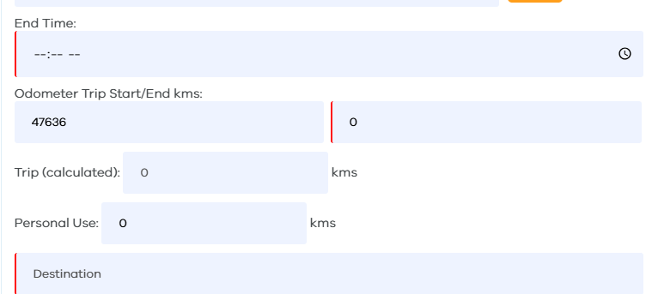

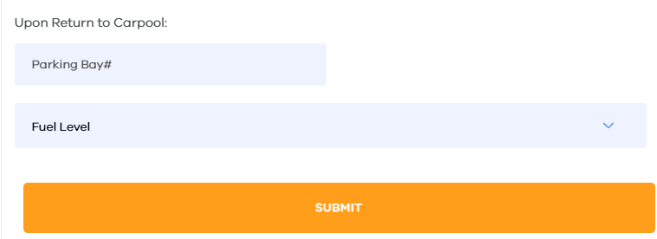

## Step 4: Save the trip

Click Save to submit your entry.

A message will confirm that the trip was logged successfully.

## Need help?

📞 ACLS Carpool Team Tel: 03 7005-9255

📧 Email: carbookings@dgs.vic.gov.au